Executive Summary:

Goal:
To study the factors affecting the median housing prices using regression techniques and evaluate the difference between each technique based on the prediction errors of each model

Approach:
- Use simple linear regression method to predict the median housing prices and use step function in R to select the best set of variables
- Use regression tree and select the best cp value for the tree thus selecting the optimal tree nodes
- Use Bagging technique to predict the median housing price. Tune the number of trees used in bagging and select the optimal value for the same and build the final model using the optimal value
- Use Random Forest technique to predict the median housing price. Tune the number of variables used in each cut and select the optimal value for the same and build the final model using the optimal value
- Use Boosting technique to predict the median housing price. Tune the number of trees used in Boosting and select the optimal value for the same and build the final model using the optimal value

Findings: 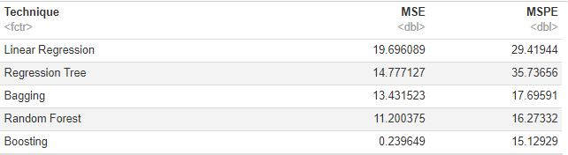
We observe that the MSE and MSPE decrease as we go down the table suggesting increase in predictive power of techniques like Bagging and Boosting as compared to traditional methods.

Linear Regression:
Built a simple linear regression model and used step function for variable selection to get to the best model.
Model Used:
medv ~ lstat + rm + ptratio + dis + black + nox + rad + tax + zn + crim + chas

Regression Tree
Built a large bushy tree by setting low value for cp and then trimmed the tree using the plotcp graph. Below is the graph:
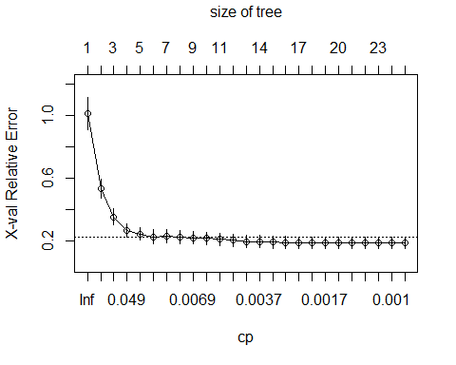
Fig 1 shows that the optimal number of nodes for the tree is around 12. We use the cp corresponding to this value to trim the tree and get to optimal tree
Fig 1

Using the optimal number of nodes, we trim the tree and calculate the in sample and out of sample errors.

Bagging
There are 13 predictors and one response variable. The bagging technique uses all the variables to find the optimal cut hence we specify mtry=13. The number of trees can be varied, and we can select the optimal number of trees based on the out of sample errors using different number of trees. Below is the variation in MSPE based on number of trees:
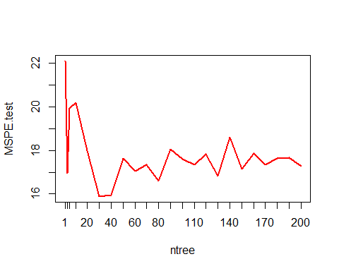
Fig 2 shows that the optimal number of trees is 30. We use this value to rerun the bagging method
Fig 2

Using the optimal number of tress, we calculate the in sample and out of sample errors.

Random Forest
There are 13 predictors and one response variable. The random forest technique default uses p/3(=4) variables at each cut. The number of variables chosen at each cut can be varied, and we can select the optimal number of variables based on the prediction errors(OOB error) using different number of variables. Below is the variation in MSPE based on number of variables:
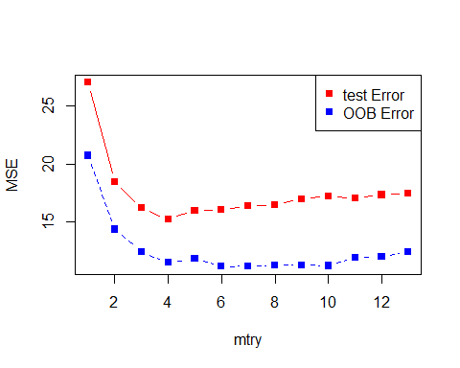

Fig 3 shows that the optimal number of variables is 6. We use this value to rerun the random forest method

Fig 3

Using the optimal number of variables, we calculate the in sample and out of sample errors.

Boosting
The boosting technique is highly sensitive to the learning rate defined by the shrinkage parameter. We set this learning rate to 0.01 which is low enough and set the interaction depth to 8. Another tuning parameter here is the number of trees. Building high number of trees can be helpful in increasing the prediction power but we observe that after a certain number of trees, the decrease in error becomes negligible. Hence to reduce the chances of overfitting, we select the optimal value of number of trees. The number of trees can be varied, and we can select the optimal number of trees based on the prediction errors using different number of trees. Below is the variation in MSPE based on number of trees:
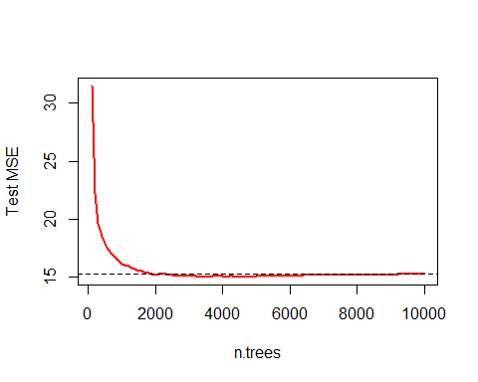

Fig 4 shows the decrease in MSPE with increase in number of trees. But after a certain point it again starts increasing. We use the ntree corresponding to min MSPE value

Fig 4

Using the optimal number of trees, we calculate the in sample and out of sample errors.

Summary:
Above table represents the decrease in MSE and MSPE as we go down the table. This tells us that the prediction power of state-of-the-art technologies like Boosting and Bagging is really high but we loose the interpretability of our models. So, if the end objective is to choose the model with high prediction power, go for boosting. If the client is not comfortable with the results, we can opt for more explanatory methods like regression tree or linear regression.

